# UAT/Staging/Live and CI Servers

## Add Connection Strings to Machine.config

In the following files:

C:\Windows\Microsoft.NET\Framework64\v4.0.30319\Config\machine.config

C:\Windows\Microsoft.NET\Framework\v4.0.30319\Config\machine.config

Copy the connections strings (in the <connectionStrings> node) in the corresponding files on the staging server to the live servers.

## Run aspnet_regiis.exe

Always seem to need to run these from the command line:

%windir%\Microsoft.NET\Framework64\v4.0.30319\aspnet_regiis.exe –i %windir%\Microsoft.NET\Framework\v4.0.21006\aspnet_regiis.exe –i

## Install MVC3

Download and run MVC3 from <http://www.asp.net/mvc/mvc3>

Download and install AspNetMVC3ToolsUpdateSetup.exe from <http://www.microsoft.com/en-us/download/details.aspx?id=1491>

## Run Reg File

Run this reg file, which contains encryption key for passwords stored in code:

\\pbsw23it\it\PbsEncryptionKey\PbsEncyrptionKey.reg

## Pull PeninsulaRuby From Mecurial.

Pull Peninsula Ruby from Mecurial to your C drive.

# CI Servers only

This does not include installing and setting up Jenkins.

## Install Ruby

Install Ruby from <http://rubyinstaller.org/downloads/>

## Install Rake

From the command line, run ‘gem install rake’

## Add required environment variables:

Add these 2 environment variables HOME=’ %USERPROFILE%\AppData\Local\Temp’ and Path=’ C:\Ruby193\bin’

## Ensure WCF Activation is checked

Go to Control Panel -> Programs – Turn on off Windows features, Features -> add Features -> Features > Add Features > Expand .Net Framework 3.5.1 Features > Check WCF Activation

## Set SQL Server to windows Authentication Mode

Configure the SQL server that the server is accessing so that Server Authentication is set to ‘SQL Server and Windows Authentication Mode’

## Install Nant

Even though Rake is our main deployment script, we still seem to use Nant for some things. This can be installed as outlined here:

<http://pbswiki/How%20to%20install%20Nant.ashx>

## Nant/Ruby Requirements

Ensure you have Peninsula Ruby and NantCommonIncludes in the C drive.

## The following are to fix certain errors you may have:

## Missing webapplication.target error

If you get the following error:

*The imported project "C:\Program Files\MSBuild\Microsoft\VisualStudio\v10.0\ WebApplications\Microsoft.WebApplication.targets" was not found. Confirm that the path in the <Import> declaration is correct, and that the file exists on disk.*

Then do the following: Create a folder ‘C:\Program Files (x86)\MSBuild\Microsoft\VisualStudio\v10.0\WebApplications’ and copy the file ‘Microsoft.WebApplication.targets’ from a similar path on a machine that has visual; studio 10 installed.

## Error where hg pull is asking for credentials and causing ccnet to hang when getting source code

Copy these files from a working server: C:\Users\Continuous.int\Mercurial.ini, C:\Users\Continuous.int\Mercurial-kiln.ini, C:\Users\Continuous.int\Mercurial.ini. Then go to kiln <http://pbsdevtools1.hq.peninsula-uk.local:8054/kiln/> , log on as continuous.int, go to resourses /KilnClient and Tools, download mercurial extensions and unzip, Described in <http://kiln.stackexchange.com/questions/2518> , then place contained files in C:\Users\continuous.int\AppData\Local\KilnExtensions. Then next hg pull will ask for login but don’t need to after that. The problem I think is that Mercurial was installed for a different user and therefore did not work for continuous.int. This should no longer be a problem when we get rid of Kiln.

## Install SQL Tools

Sometimes you may find you need to install the following features:

Microsoft® SQL Server® 2008 R2 Native Client

Microsoft® SQL Server® 2008 R2 Command Line Utilities

From this page:

<http://www.microsoft.com/en-us/download/details.aspx?id=16978>

Then add this to the PATH environment variables: ‘C:\Program Files\Microsoft SQL Server\100\Tools\Binn’

You’ll need to do this if you get the message:

'C:\Program Files\Microsoft SQL Server\100\Tools\Binn\sqlcmd' failed to start.

The system cannot find the file specified

## DTC

Enable dtc on the uat sql server and the uat web server.

Set dtc security

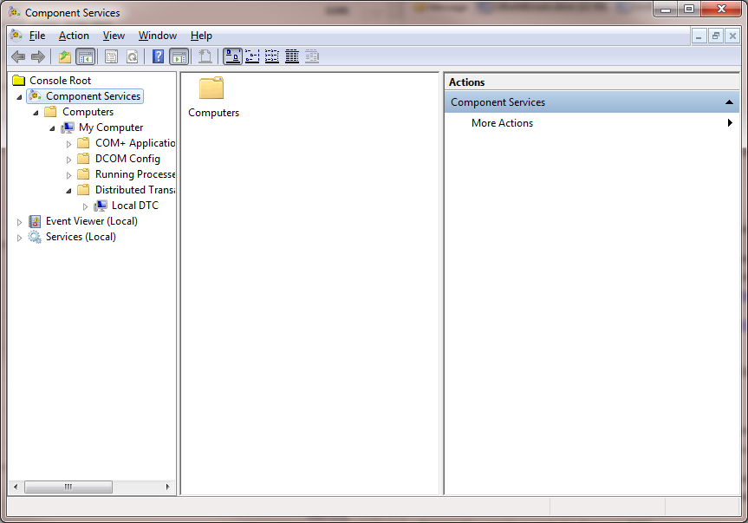

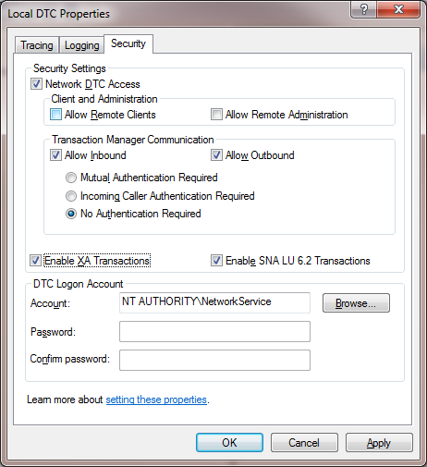

Use dtc ping <http://www.microsoft.com/en-gb/download/details.aspx?id=2868> to test dtc between the uat web server and the sql server

If the uat machine has been created from an image it is likely that the CID is the same. This will cause issues. To resolve uninstall dtc **%WINDIR%\System32\msdtc.exe** **-uninstall** and reinstall **%WINDIR%\System32\msdtc.exe –install**.